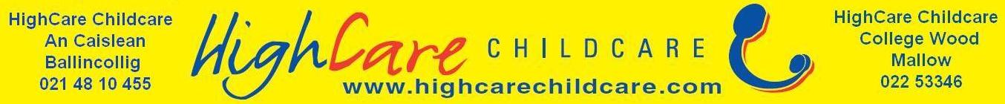
Please return this booking form along with the €50 enrolment fee to secure your child’s place.
Afterschool and Breakfast Club Booking Form
Child’s name:_______________________
D.O.B: ____________________________
School your child attends: _____________
Class your child is in: ____________________
Name of your child’s teacher: _______________
Start date of which you require care:______________________

Any Allergies:_____________________________
Parent Contact Numbers: _______________________________________
Parents Email:

Have you received a text from the After School Phone 0878586411 ?

Yes |  | No

Yes |  | No
Is your child allowed on HighCare Childcare’s facebook page?

Time of drop off to school:
Time of pick up from school:
(Please note for afterschool collections we are unable to facilitate collections from extra curricular activities.)
Please tick accordingly the days you require each week:

Days | Breakfast Club | Afterschool Club
Monday
Tuesday
Wednesday
Thursday
Friday
We ask that you send us a copy of any school holidays, closures, half days or in service days as soon as you recieve them.Thank you.

